**KENDRIYA VIDYALAYA NAGROTA**

**HOLIDAYS HOMEWORK FOR SUMMER VACATION**

**SESSION (2021-22)**

**CLASS:-2nd**

**ENGLISH**

1. Learn poems First day at school ,

The paddling pool and I am lucky

2. Do one page writing daily.

3. Write 10 rhyming words.

4. Write and learn names of 10 pet, wild and animals that live in water.

5 Learn and write 5 lines on my school and on my pet.

6. Learn and write days of the week.

7. Make masks of happy, sad, shy and angry faces.

**HINDI**

1) 20 सुलेख लिखें ।  
2 ) हिन्दी पाठ्य पुस्तक के प्रथम चार पाठ पढ़ें व पाठ में आए कठिन शब्दों को लिखें ।  
3 ) 25 श्रुत लेख लिखें ।  
4 ) ऊँट चला और म्याऊँ म्याऊँ कविता याद करें व सस्वर गायन   
5) प्रतिदिन एक पृष्ठ पढ़ें ।  
6 ) ऊँट, भालू और बिल्ली का चित्र बनाएँ व प्रत्येक के बारे मे पाँच पाँच पंक्तियाँ लिखें ।  
7) इ ई,उ ,ऊ, ओ व औ मात्रा के 10- 10 शब्द लिखें।

**MATH**

**WEEK 1**

1. Write numbers and their number names from 100-120

2. Learn table of 2 and 3

3. Paste 5 two dimensional objects

4. 5 sums of addition(3 digit number)

**WEEK 2**

1. Write numbers and their number names from 121-140

2. Learn table of 4 and 5

3. Paste 5 three dimensional objects

**WEEK 3**

1. Write numbers and their number names from 141-160

2. Learn table of 6 and 7

3. Paste 5 sliding objects

**WEEK 4**

1. Write numbers and their number names from 161-180

2. Learn table of 8 and 9

3. Paste 5 rolling objects

**WEEK 5**

1. Do 5 sums of subtraction (3 digit number)

2. Make a picture using shapes( page 44)

**EVS**

1. Learn the names of ten body parts.
2. Learn five sense organs and their uses.
3. Learn the names of yours family members

Write answers of the following questions and learn

Q1. What type of family do you live in?

Q2. Write three duties your father performs for the family?

Q3. Write three duites your mother performs for the family?

Q4. Write three duties you perform for your family?

Q5. Who helps you in studies in your family?

Q6. Who is the tallest memebers of your family?

Activites

1. Paint your palm and print it on a paper. Print your mother’s palm and see the difference.
2. Past two photographs of yours when you were a baby and how you look now. Also paste a photograph of your parents. Whom do you resmble?
3. Collect or draw five sweet, sour, salty, and bitter things.
4. Write ten vegitables & friuts and write their regional name.
5. Draw a family tree.

**KENDRIYA VIDYALAYA NAGROTA**

**HOLIDAYS HOMEWORK FOR SUMMER VACATION**

**SESSION (2021-22)**

**CLASS:-3RD**

**ENGLISH**

1.Write one page of handwriting daily.

2.Write a paragraph on “ my beautiful garden".

3.Write 10 rhyming words and 10 opposite words.

4.Learn the poem “ good morning”.

5. Write 30 difficult words with there meaning.

6.Revise all the chapters and poems done till now in class.

**HINDI**

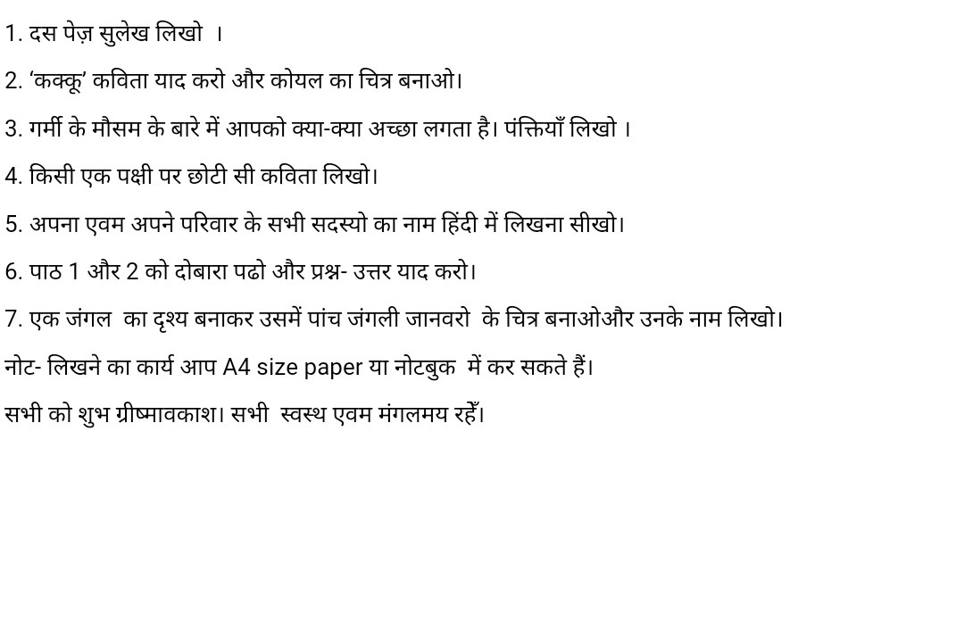

**MATH**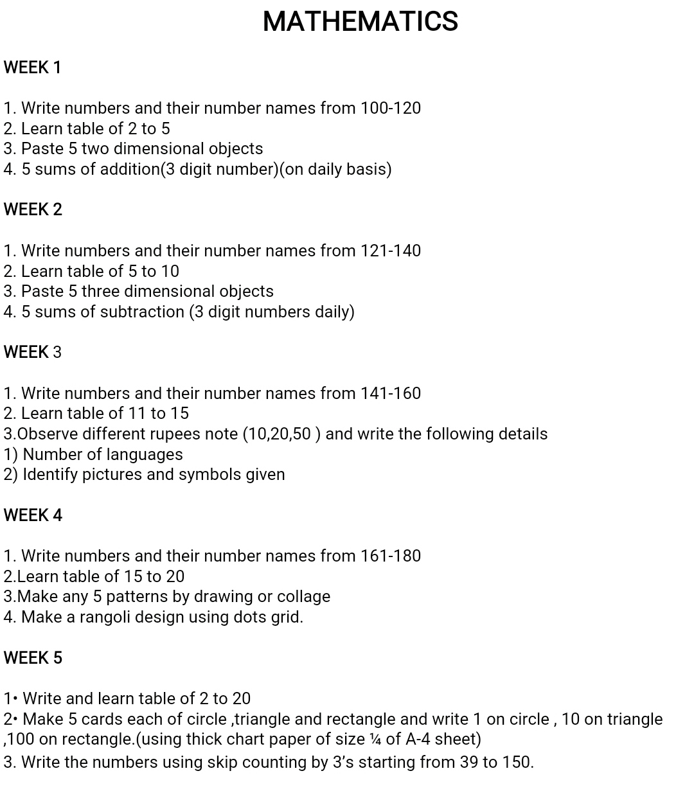

**EVS**

1. Make a jigsaw puzzle using a picture of any animal. Paste the picture on a cardboard. Now, cut the cardboard along the edges of the picture. Cut this cardboard into unequal pieces.

and you may play with your friends or family members.(Page-9)

1. Plant a tree and observe its changes and write about it.

(5 lines)

1. **Fun with colours**

Take a paper and fold it in the middle. Now unfold it and put some drops of different colours on it. Fold the paper again and press it. Unfold the paper and paste this picture (Page24)

1. Write two slogans to save water.
2. Draw or paste five sources of water.
3. Name two animals that

A- can hop _____ _____

B- Can jump _____ _____

C- Live on tree _____ _____

D- Have tail _____ _____

E- Give milk _____ _____

1. Write 5 things we get from plants.
2. Learn first three chapters of EVS book.

**KENDRIYA VIDYALAYA NAGROTA**

**HOLIDAYS HOMEWORK FOR SUMMER VACATION**

**SESSION (2021-22)**

**CLASS:-4TH**

**ENGLISH**

1.write 20pages of English handwriting.

*write comparative and superlative degrees of the following adjectives

a)good. b)sweet. c)lovely. d)intelligent. e)cute. f)bad. g)lonely. h)funny

2.learnalltheq/a&grammarexercisedonebeforesummerbreak. alsoread2pagesinengeveryday(textbook/storybook) 3.prepareaclockandlearntoreadtimeinenglishfromthat(eg-11:30saysit'shalfpasteleven) 4.•readthefollowingpassageandanswerthefollowingquestions: hariisastudentofclass4.heisthemonitorinhisclass.hegetsupat6 o’clock.hehashisbreakfastat8o’clock.afterbreakfast,heputsonhis uniformandgoestoschoolat10am.hisschoolgetsoverat2o’clock.he takeshislunchafterhereturnsfromschool.intheafternoon,hegoestothe fieldtoplaywithhisfriends.hedoeshishomeworkintheevening.after dinner,hewatchestvandthengoestobedat10pm. a)haridoeshishomeworkinthe1)morning2)afternoon3)evening b)hegoestothefieldtoplaywithhis1)brother2)friends3)sister c)hariisa…………ofclassfour.(boy/girl) d)whendoesheputonhisuniform? e)whattimedoesharigetupinthemorning? 5.takeupthischallengeandwrite fullnameofyourfatherhisfavoritefoodhisfavoritegamehisfavoritecolour-

hisoccupation/hispostinofficehiscontactno.- hisofficeaddressfullnameofyourmotherherfavoritecolourheroccupationherfavoritemoviehercontactno.- herfavoritefoodherhobbies6.write10sentencesonhowareyoudoingduringthislockdownperiod? note-allthisworktobedoneinaseparateholidayhomeworknotebookforenglish coveritproperlyandwriteyourdetailsinit. complusarytoattemptallthetasksassigned

**HINDI**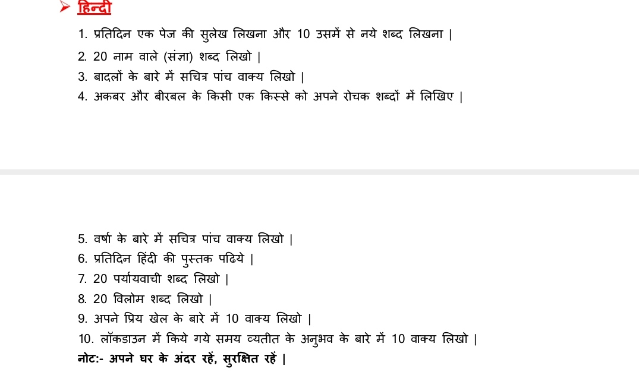

.

**MATH**

Q1:-Write and learn the Tables from 6 to 20

Q2:-Write in words the following questions:-

(i) 1001 to 1099

(ii) 6300 to 6399

(iii) 9230 to 9260

(iv) 3000 to 3030

Q3:- Solve the questions from Chapter no.1

Q4:-Solve the questions from Chapter no. 2

**EVS**

# Write the states, u.t and capitals of India. (3 times ) and learn .

# locate all Indian states in India's political map.

# write the name of trees and animals found in dessert and paste there pictures.

# Read the chapter "The story of Amrita " and write about the Khejadli tree.

# Read the cahpter "Omana's Journey" and write 4-5 lines about bee keeping.

# learn the first three chapters of your EVS book.

# Draw the pictures of following

* Bees
* Khejadli tree
* Elephant
* Jugad

**KENDRIYA VIDYALAYA NAGROTA**

**HOLIDAYS HOMEWORK FOR SUMMER VACATION**

**SESSION (2021-22)**

**CLASS:-5TH**

**ENGLISH**

|  |  |  |  |
| --- | --- | --- | --- |
| **COMPETENCIES** | | | |
| **LISTENING** | **SPEAKING** | **READING** | **WRITING** |
| 1. Listen to your family members and friends and respond them with utmost love. 2. Listen to 1 English rhyme per week on YouTube etc.      1. Listen to   English news daily for at least 10 minutes. | 1. Speak to your family members and friends with respect and love. 2. Speak to your family members and friends exclusively in   English for at least 1 hours (5.00pm to 6.00 pm or as per your choice) | 1. Read one moral story per week. Tell the same story with moral to your family members and friends. 2. Read an English newspaper/e-paper loudly for 20 minutes daily. 3. Read and revise Unit-1 & 2 of your textbook thoroughly. | 1. Do any 15 good deeds that helped you to gift a smile to someone. Write the deed and get it signed by the person with a happy-comment.   (1/2 of a chart)   1. Write any 10 activities that you enjoyed doing in your vacation in detail. (on a chart) 2. Write the all questions of given question bank. |

**SUMMER VACATION QUESTIONS BANK**

* **CHAPTER-1 ICE-CREAM MAN**

Ques.1 In which season is ice-cream popular?

Ques.2 Who feels joyful on seeing the Ice-cream Man?

Ques.3 Name the different flavors of ice-cream.

Ques.4 What are the two things that the Ice-cream man is selling?

Ques.5 What is the ice-cream cart compared to in the poem?

Ques.6 Having an ice- cream on a hot summer day is exciting and enjoyable. Ques.7 List as many summere activities as you can.

* **CHAPTER-2 WONDERFUL WASTE!** 
  + ONE WORD QUESTION ANSWER

Ques.1 Who ordered a grand dinner?

Ques.2 Where did he order a grand dinner?

Ques.3 Who entered the kitchen to survey?

Ques.4 What was the name of the new dish prepared by the cook?

Ques.5 In which state avail is treated as the traditional feast?

Ques.6 Who named the new dish?

Ques.7 Was the new dish really enjoyed by the guest?

SHORT QUESTION ANSWER

Ques.1 What were the preparations in the palace for?

Ques.2 What had the cook planned to do with the vegetable scraps ?

Ques.3 Why did the maharaja go in the kitchen in the afternoon? Ques.4 Why was the cook staring at the vegetable scraps?

* **CHAPTER- 3 TEAMWORK** 
  + - ONE WORD QUESTIONS AND ANSWER

Ques.1 Why was the shoe lost?

Ques.2Why was the horse lost?

Ques.3Why was the rider lost?

Ques.4Why was all lost?

Ques.4 Why do we need a rider?

Ques.5 Why all of this was happen?

Ques.6 Name the poet of the poem “Teamwork”?

Ques. 7 What will be “Big plus” for us?

* + - SHORT QUESTIONS

Ques.1 define the term teamwork?

Ques.2 What will happen if no one will pass the ball in a basketball game?

Ques.3 What will happen if no will pass the baton in a relay race? **Revise, understand and learn all exercise of chapters 1,2 & 3.**

**HINDI**

1. पाठ 1-3 तक कक्षा में कराए गए सभी प्रश्न-उत्तर याद करें l
2. व्यक्तिवाचक, जातिवाचक संज्ञा के 10- 10 उदाहरण लिखो l
3. 20 काम वाले शब्द लिखो l
4. 15 पेज सुलेख लिखें l
5. खिलौनेवाला कविता में प्रसिद्ध ग्रंथ रामायण की कथा का वर्णन किया है l इस कथा से संबंधित एक पर्व मनाया जाता है, जिसमें बुरे पर अच्छे की जीत है l उस पर्व का नाम लिखकर उसके बारे में पांच वाक्य लिखिए l
6. निम्नलिखित त्योहार कहाँ और कैसे मनाए जाते हैं? लिखिए l

1 पोंगल 2. बिहू 3. पतंगों का पर्व

1. लॉकडाउन के समय में आप अपना समय कैसे बिताते है? दस पंक्तियां लिखें l

**MATH**

1. Learn tables from 2 to 15 (table book already prepared)
2. Solve all the sums of unit 1 in your note book.
3. Draw three fishes using Geometrical shapes only.
4. Make a dice/cube using in playing ludo with the help of used boxes.
5. Prepare Indian and international place value chart and write 10 numbers and their number names. (9 digit numbers)
6. Go through the unit 2 and prepare different angles using match sticks.
7. Prepare a model of clock showing 2 hands making right angle.
8. Use Google search, find different kinds of fish and paste their pictures/or Draw.

**EVS**

.1Learn all the exercises done in the class.

2. Put the seeds in small packets and paste in A4 sheets.

3. Make Human Digestive Model with the help of clay or draw it on A-4 sheet.

4. Find out different national parks in India and name the states in which they are situated.

5. Germinate a seed in a pot and write your observation daily.

6. Draw or paste pictures of different water resources.

7 Make a puppet of an animal.

8. Find the correct way of disposal of e- garbage (write a report)

9. Collect information about any five historical places in Delhi.

10. Collect and write the information about snakes in India.

**KENDRIYA VIDYALAYA NAGROTA**

**HOLIDAYS HOMEWORK FOR SUMMER VACATION**

**SESSION (2021-22)**

**CLASS:-6TH**

**ENGLISH**

<http://iteslj.org/cw/3/ck-dolch15.html>

**Instructions: -**

•

Do this assignment in A-4 Sized sheets and duly paste in a file.

1.

Learn to make sentences while playing this language game. Write down these sentences on an A-4 size sheet. The link to the worksheet is <https://www.gamestolearnenglish.com/fast-phrases/>

Riddles have forever been a part of our lives. They are a great way of learning. Let's see how many of you can guess these riddles. Write down these riddles on A-4 size sheets. Students can include their own riddles and have a collection of their own. You can access the riddles from [https://www.eslkidsgames.com/Flash/ESL%20Brain%20Teasers/ESL%20Brain%20T](https://www.eslkidsgames.com/Flash/ESL%20Brain%20Teasers/ESL%20Brain%20Teasers.html) [easers.html](https://www.eslkidsgames.com/Flash/ESL%20Brain%20Teasers/ESL%20Brain%20Teasers.html)

Solve the following crossword puzzles and make the same on the A-4 size sheets. Do write the sentences along with words.

<http://iteslj.org/cw/3/ck-dolch07.html> <http://iteslj.org/cw/3/ck-dolch09.html>

2.

3.

4. You are Sumit of 7A, Raavi Apartments, Sarita Vihar, New Delhi.

You have lost your leather wallet containing your examination admit card while travelling by bus from Sarita Vihar to Punjabi Bagh. Write a notice in not more than 50 words to be published in 'The City Times'.

5. You have found a blue Milton water bottle in your school playground. Write a notice giving relevant details about the same in not more than 50 words.

6. Revise whole syllabus done in the class during your vacations.

**HINDI**

*कक्षा में कराए गए कार्य को पूरा करें व याद करें ।*

*2. संज्ञा व सर्वनाम की परिभाषा लिखो ।*

*3. 20 विलोम शब्द लिखो ।*

*4. 20 मुहावरे व उनके अर्थ लिखो ।*

*5. निबंध लिखो*

*1. मेरा प्रिय त्योहार*

*2. मेरा देश*

*3. खेलों का महत्व*

*6. पत्र लिखो – प्रधानाचार्य को दो दिन के अवकाश हेतु पत्र ।*

**MATH**

* Revise all the concepts and questions of the chapters done in the class(upto chp- 2)
* Write all the questions and answers of your textbook on a separate notebook for following chapters:

1. Playing with numbers
2. Whole numbers
3. Basic geometrical ideas

* Project: write all the Formula and important concepts of chp 1 to 8 from your textbook. Also learn them.

**SCIENCE**

1. Write the names of different types of foods of India (atleast 10) along with their ingredients.

2.Write the names of herbivores, carnivores and omnivores (5 each).

3. List the table of deficiency disease along with the vitamin/mineral required and also the symptoms of the disease.

4. Collect the original fibres of different types and paste them in the home work note book.

5. Make the sprouts of moong daal and black grams yourself to develop nutritious food habit.

6. Prepare all the chapters done in class for PERIODIC TEST 1

7. Questions from 1to 4 are to be done in homework notebook.

**S.ST**

**Do all the work in a A4 size paper.**

1.On an outline Political map of India mark and label: a) Indian states and their capital

2. On an outline Physical map of India mark and label the following: b) Mountains: Himalayan Mountain, Vindhyas, Satpurac) Rivers: Ganga, Narmada, Tapi and Brahmaputra3. Draw:a) Solar systemb) Indian National Flagc) Indian National Flowerd) Indian National Animale) Indian National bird4. Write Indian National Anthem5. Choose any 5 states of India and mention the following about them:a) Festivalsb) Foodc) Dressd) Art and architecture.6. Make a manuscript: Take a broad leaf. Put it under a heavy book for ten days. On the leaf write why do we study Social Studies.

7.Revise all the syllabus that have completed in the class.

8.Write do's and don'ts of COVID-19 with pictures.

9.Collect three newspaper headlines of national, international and sports event each and write in notebook.

10.Write 5-5 extra long questions of each chapter that have done in the class.

**SANSKRIT**

संस्कृत ग्रीष्मावकाशस्य गृहकार्यम् 2021-22

विषय:- संस्कृत

कक्षा-

* प्रश्न 1. प्रथमः पाठ: - शब्दपरिचय:-१
* पाठे आगतानां अभ्यास प्रश्नानां लेखनकार्यम् तथा च तेषां स्मरणम्।
* प्रश्न 2. द्वितीयः पाठ: - शब्दपरिचय: -२
* पाठे आगतानां अभ्यास प्रश्नानां लेखनकार्यम् तथा च तेषां स्मरणम्।
* प्रश्न 3. अधोलिखितानां शब्दानां विभक्ति-रूपाणि लिखत्।
* बालक, बालिका, पुष्प
* प्रश्न 4. “पठ्” धातोः लट्, लृट् लकारान् लिखत्।
* प्रश्न 5. एकतः प्रारभ्य विंशति: (1- 20 ) पर्यन्तम् संस्कृत संख्यां लिखत।

**KENDRIYA VIDYALAYA NAGROTA**

**HOLIDAYS HOMEWORK FOR SUMMER VACATION**

**SESSION (2021-22)**

**CLASS:-7TH**

**ENGLISH**

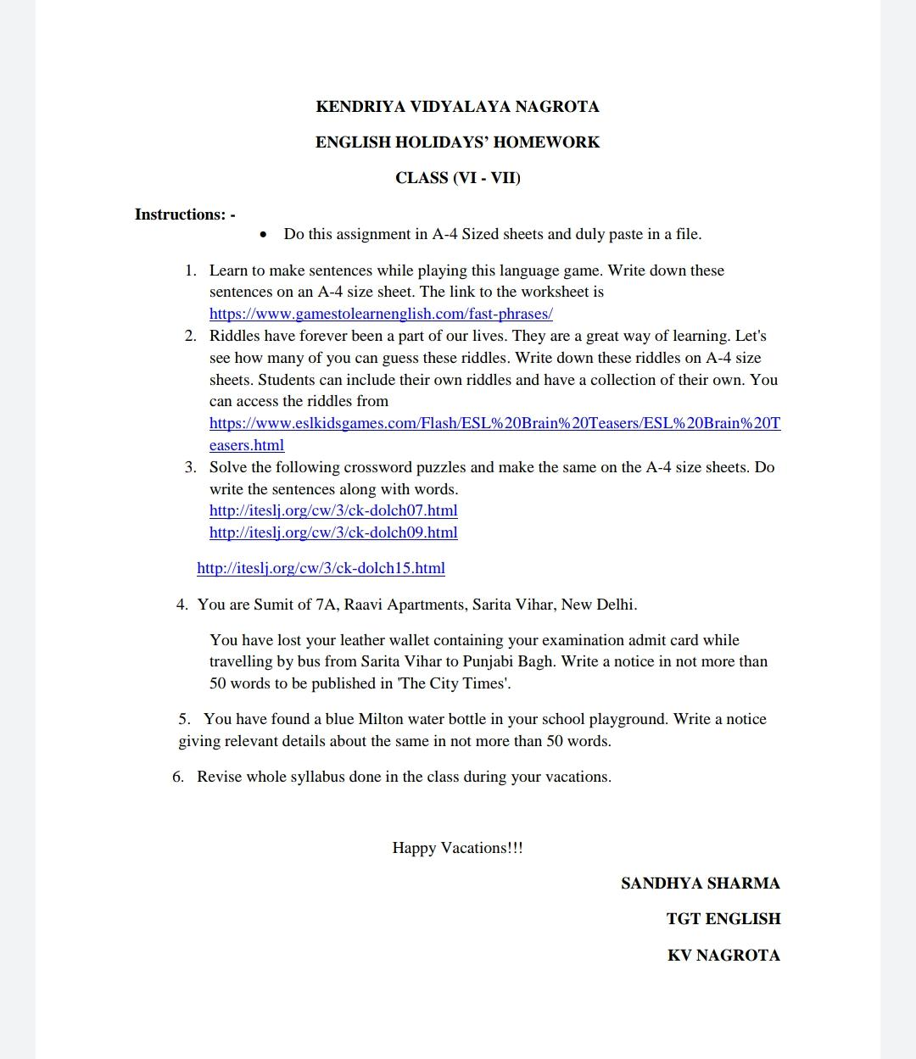

**HINDI**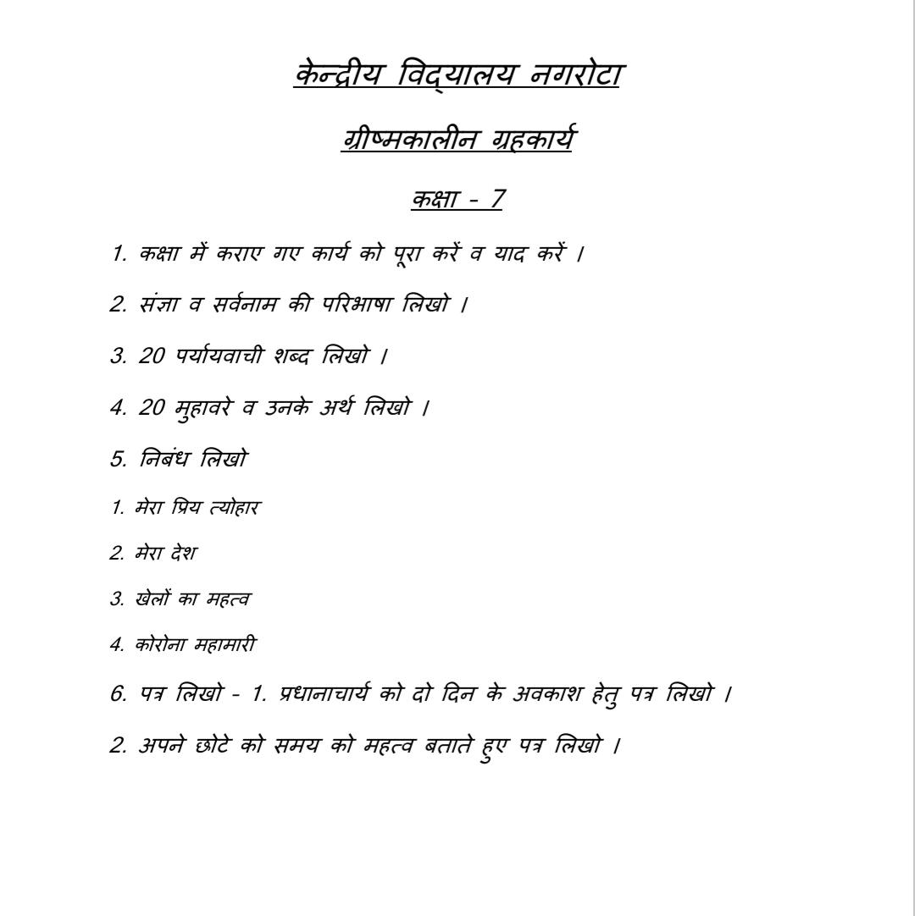

**MATH**

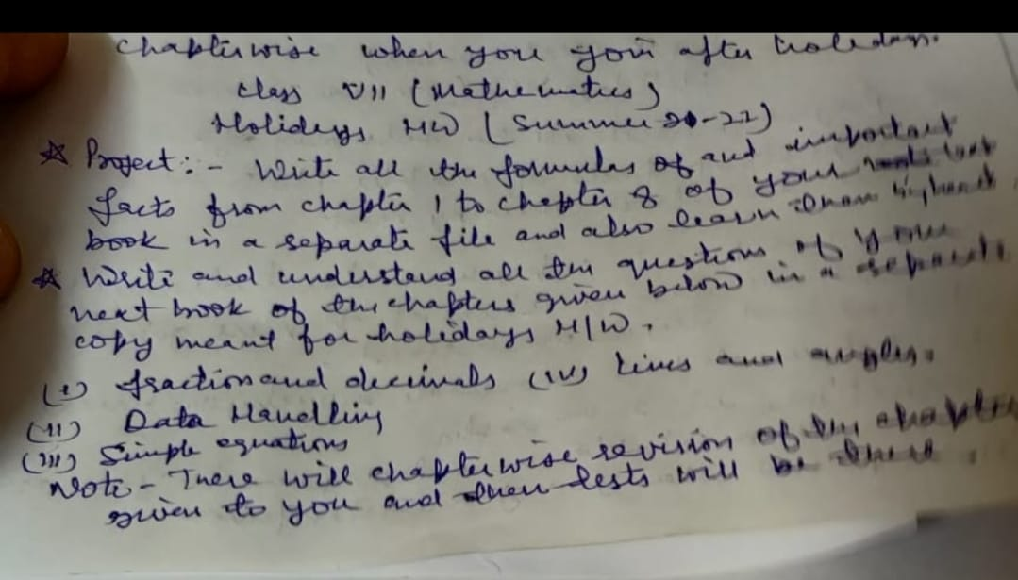

**SCIENCE**

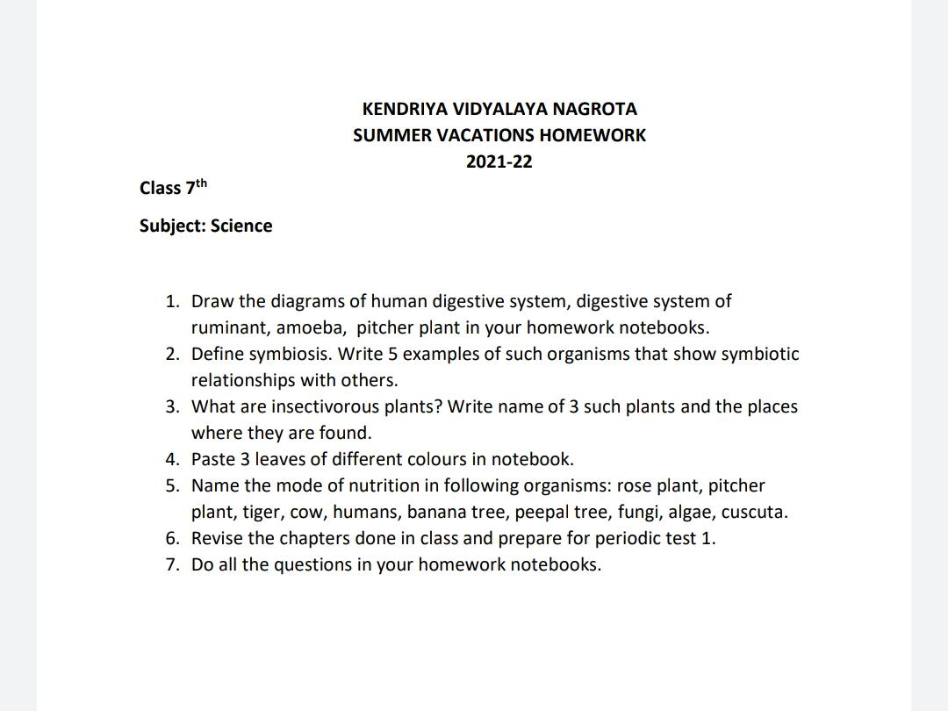

**S.ST**

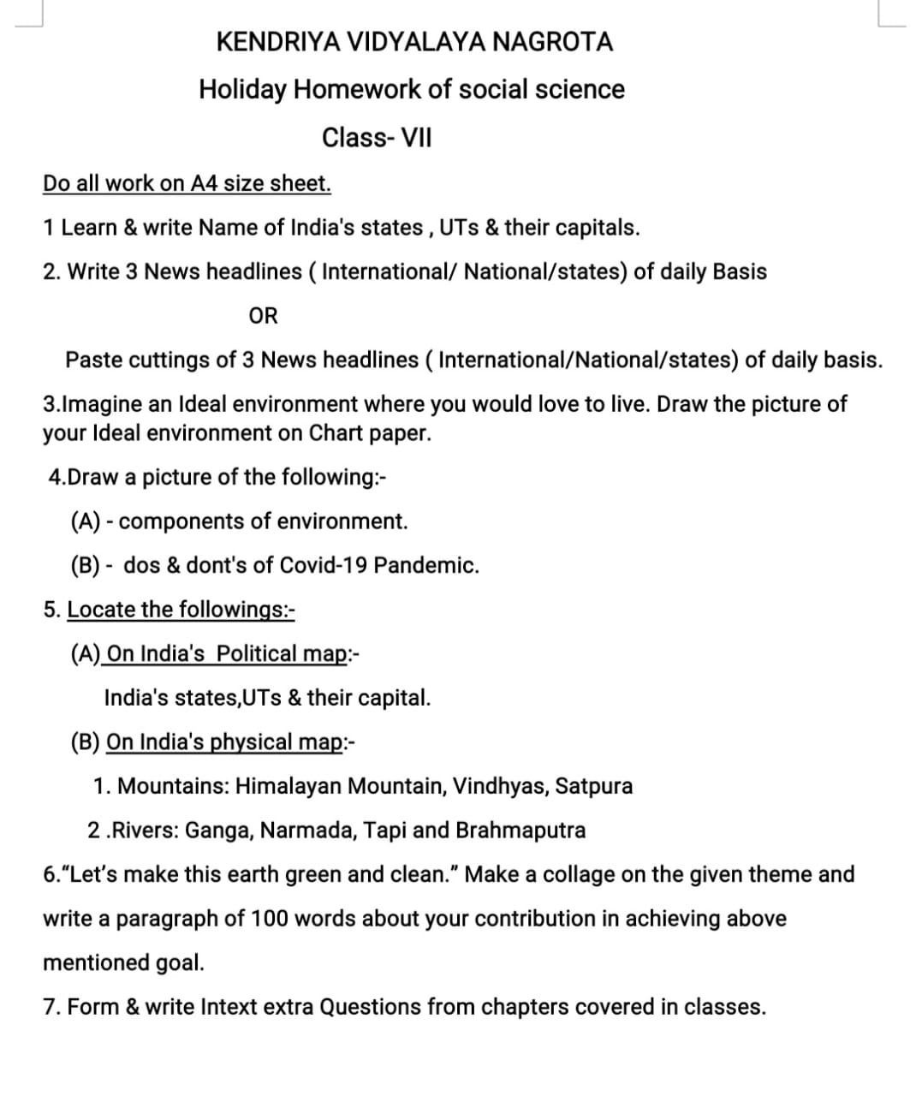

**SANSKRIT**

संस्कृत ग्रीष्मावकाशस्य गृहकार्यम् 2021-22

विषय:- संस्कृत

कक्षा- सप्तमी

प्रश्न 1. प्रथमः पाठ: - सुभाषितानि

पाठे आगतानां श्लोकानां अर्थ-सहितं स्मरणम् तथा च अभ्यास प्रश्नानां लेखनकार्यम् ।

प्रश्न 2. द्वितीयः पाठ: - “दुर्बुद्धि: विनश्यति”

पाठे आगतानाम् अभ्यास प्रश्नानां लेखनकार्यम् तथा च तेषां स्मरणम्।

प्रश्न 3. अधोलिखित शब्द-रूपाणां लेखनकार्यम् तथा च स्मरणम् ।

एतत् (पुल्लिङ्गे)

एतत् (स्त्रीलिङ्गे)

एतत् (नपुंसकलिङ्गे)

प्रश्न 4. “कृ” धातोः लट्, लृट्, लङ् लकारानां स्मरणम् तथा च लेखनकार्यम् ।

प्रश्न 5. एकत: प्रारभ्य पञ्चाशत् ( 1- 50 ) पर्यन्तम् संस्कृत संख्याया: लेखनं-स्मरणञ्च ।

**KENDRIYA VIDYALAYA NAGROTA**

**HOLIDAYS HOMEWORK FOR SUMMER VACATION**

**SESSION (2021-22)**

**CLASS:-8TH**

**ENGLISH**

**HINDI**

. कक्षा में कराए गए कार्य को पूरा करें व याद करें ।

2. निबंध लिखो -1. नारी शिक्षा का महत्व 2. पुस्तकालय का महत्व 3. मेरी पहली रेल य हवाई यात्रा 4. कोरोना महामारी व उसके अनुभव 3. पत्र लिखो –1. स्वास्थ्य अधिकारी को अपने क्षेत्र की सफाई हेतु पत्र लिखो । 2. अपने छोटे को समय को महत्व बताते हुए पत्र लिखो ।4. दो मित्रों के बीच कोरोना महामारी पर संवाद लीखों । 5. 20 मुहावरे लिखकर उनका वाक्य प्रयोग कीजिए ।

**MATH**

Revise all the concepts and questions of the chapters done in the class(upto chp-2)• Write all the questions and answers of your textbook on a separate notebook for following chapters:(a) Understanding quadrilaterals(b) Practical geometry(c) Data handling.• Project: write the important formulas, properties used from the chapters from your textbook and write different congruency criterion of similarity in triangles*A revision and test of the chapters will be done after school reopens.**SCIENCE**

**Chapter 1** Crop production and managementWrite the text book question in holiday note book and learn for periodic test.**Chapter2** micro organisms friends and foe, Write the text book question in holiday note book and learn for periodic test. **Activities of chapter s**Collection of cereals, pulses, and oil yielding seed and fix in activity copy,Paste picture of agricultural implements used in preparation soil, seed drill, types of irrigation, sickle, harvesters, and thresher,Paste the picture of useful micro organisms and name of products produce by them,Paste the picture of harmful organisms and diseases caused by them **Subject enrichment:** Draw the picture of hoe, plough, drip and sprinkler irrigation system. Draw the diagram of different micro organisms, nitrogen cycle  **Practice CCT** Write questions of CCT in separate note book

**S.ST**

1.“Let’s make this earth green and clean.” Make a collage on the given theme and write a paragraph of 100 words about your contribution in achieving above mentioned goal. 2.Know your constitution Paste pictures of five leaders who played major role in making of Indian constitution and also write down important information related to Indian constitution.3.“Rahiman Pani Rakhiye bin pani sab soon Pani gaye na upere moti manus chun.” What type of resource is the poet referring to? Write in 100 words what would happen if this resource disappeared? Also paste relevant pictures to support your write-up.4.Learn and Write all the syllabus that have been done in the class.5.Write 5-5 extra short and long questions of all the chapter that have done in the class6.Prepare a chart of do's and don'ts of Covid-19 with pictures.7.Make a chart of classification of resources.8.On the political map of India locate states and its capital.9.Write the records of daily weather conditions from the newspaper like maximum temperature of the day, minimum temperature of the day in your notebook daily and make a analysis at last.10.Prepare a chart on features of Indian constitution.

**SANSKRIT**

विषयः- संस्कृत

कक्षा- अष्टमी

प्रश्न 1. प्रथमः पाठ: - “सुभाषितानि”

पाठे आगतानां श्लोकानाम् अर्थ-सहितं स्मरणं तथा च अभ्यास प्रश्नानाम् लेखनं स्मरणमञ्च ।

प्रश्न 2. द्वितीयः पाठ: - “बिलस्य वाणी न कदापि मे श्रुता”

पाठे आगतानाम् अभ्यास प्रश्नानां लेखनकार्यम् तथा च तेषां स्मरणम् ।

प्रश्न 3. अधोलिखित शब्द-रूपाणां लेखनकार्यम् तथा च स्मरणम्।

अस्मद्,

युष्मद्

प्रश्न 4. “खाद्” धातोः लट्, लृट्, लङ् लोट् लकारानां स्मरणम् तथा च तेषां लेखनकार्यम् ।

प्रश्न 5. एक पञ्चाशतत: प्रारभ्य शतम् (51 – 100 ) पर्यन्तम् संस्कृत संख्यायाः लेखनकार्यम् तथा च स्मरणम् ।

**KENDRIYA VIDYALAYA NAGROTA**

**HOLIDAYS HOMEWORK FOR SUMMER VACATION**

**SESSION (2021-22)**

**CLASS:-9TH**

**ENGLISH**

1. Listen to English News Channel everyday for atleast 10 minutes. Write down major headlines related to COVID-19 date-wise to trace the development of the pandemic. You may include pie-charts, tables or flow charts to depict the pandemic in detail. This work is to be done on A-4 size sheets.informative and colourful project is expected.
2. Narrate and record a story of not more than 5 minutes having a moral. You can record this in your phones. Focus on good story, words, expressions and quality should be there. Submit the recording after the vacations.
3. Some senior citizens in your neighbourhood are very badly neglected and humiliated by their own sons and daughters-in-law. Such incidents have touched your heart. You want to show your concern through a letter to the Editor of any national daily of Delhi. You are Harsh/Harsha of D2, B Block, Pitam Pura, Delhi.
4. There has been a spurt in the cases of violence due to parking space in the residential colonies. Every now and then you see people in your neighbourhool quarrelling over occupying parking space. This has actually become a serious problem. Write a letter to the Editor of a national daily sharing your views on this issue. You are Purva/Parth staying at SU-181, Pitam Pura, Delhi. You may include the hints given below— — increase in the number of cars —parking cars on roads in front of houses —no parking space for house owners — brawls & quarrels — manhandling —ill-feelings among people.
5. . You are Anushka/Aniket staying at B-16 Kalindi Apartments Sector9, Dwarka. There are no street lights on the main road leading to this society. The road gets very dark after seven in the evening resulting in the possibility of some accident or mishap. Write a letter to the editor of a national daily directing the attention of the concerned authorities towards it.
6. Revise the syllabus done till date for a test after vacations.

**HINDI**

1. उपसर्ग और प्रत्यय की परिभाषा व उदाहरण लिखिए ।

2. कोई एक कविता या कहानी लिखिए जिसमें आपके सपनो का वर्णन हो जो आप अपने जीवन मैं करना चाहते हो ।

3. हिंदी व्याकरण अलंकार विषय पर एक प्रोजेक्ट फ़ाइल बनाए ।

4. निम्नलिखित विषयों पर लगभग 100 शब्दों मैं अनुच्छेद लिखिए-

(क) स्वच्छ भारत एक कदम स्वच्छता की ओर ।

(ख) कोरोना वायरस : एक महामारी ।

5. अपने नगर में पेय जल की समस्या की और ध्यान दिलाते हुए स्वस्थ अधिकारी को पत्र लिखिए।

6. आपकी अपने प्रिय मित्र से किसी बात पर अनबन हो गई थी किंतु अब आपको अपनी गलती का एहसास हो गया है उसे मनाने के लिए पत्र लिखिए।

7. कक्षा में कराए गए कार्य की पुनराव्रति कीजिए ।

**MATH**

* Revise all the concepts and questions of the chapters done in the class

(upto chp-2)

* Write all the questions and answers of your textbook on a separate notebook for following chapters and try to understand them also:

1. Coordinate geometry
2. Linear equations in two variables

* **Project**: write the important formulas, used and importang concepts from the chapters 1-8 from your textbook and write all types of quadrilaterals with their properties.

*A revision and test of the chapters will be done after school reopens.

**SCIENCE**

1. "The ozone hole is steadily repairing itself".

A.What is the reason behind this?

B. What do you mean by ozone hole?

C. What are the reasons for formation of ozone hole?

2. Write a short note on Plasma- a new state of matter?

3. Derive the three equations of motion graphically.

4. Prepare the chapters done in class.

5. Learn symbols of 20 elements

**S.ST**

1(a)On the map of France locate Bordeaux, Nantes, Marseilles and Paris.

(b)On the map of India locate States with their capital,tropic of Cancer, standard meridian.

2.Prepare 5-5 mcqs,3 marks questions,5 marks questions from all the four chapter that have done in the class.

3.Prepare a project on Disaster management .It should be decorated by pictures and latest records.

Instructions regarding project:

A.You have to use A4 size sheets.

B.It should be in neat and clean hand writing.

C.You have to paste or draw pictures related to the topic.

D.It should be compiled in 15-20 Pages with your conclusion.

4.Prepare a chart showing precautions taken in this critical situation of Covid-19.

5.Make a PowerPoint presentation regarding French revolution,it's features and effects.

6.Learn all the syllabus that have completed in the class.

**KENDRIYA VIDYALAYA NAGROTA**

**HOLIDAYS HOMEWORK FOR SUMMER VACATION**

**SESSION (2021-22)**

**CLASS:-10TH**

**ENGLISH**

1. Listen to English News Channel everyday for atleast 10 minutes. Write down major headlines related to COVID-19 date-wise to trace the development of the pandemic. You may include pie-charts, tables or flow charts to depict the pandemic in detail. This work is to be done on A-4 size sheets.informative and colourful project is expected.
2. Narrate and record a story of not more than 5 minutes having a moral. You can record this in your phones. Focus on good story, words, expressions and quality should be there. Submit the recording after the vacations.
3. Some senior citizens in your neighbourhood are very badly neglected and humiliated by their own sons and daughters-in-law. Such incidents have touched your heart. You want to show your concern through a letter to the Editor of any national daily of Delhi. You are Harsh/Harsha of D2, B Block, Pitam Pura, Delhi.
4. There has been a spurt in the cases of violence due to parking space in the residential colonies. Every now and then you see people in your neighbourhool quarrelling over occupying parking space. This has actually become a serious problem. Write a letter to the Editor of a national daily sharing your views on this issue. You are Purva/Parth staying at SU-181, Pitam Pura, Delhi. You may include the hints given below— — increase in the number of cars —parking cars on roads in front of houses —no parking space for house owners — brawls & quarrels — manhandling —ill-feelings among people.
5. . You are Anushka/Aniket staying at B-16 Kalindi Apartments Sector9, Dwarka. There are no street lights on the main road leading to this society. The road gets very dark after seven in the evening resulting in the possibility of some accident or mishap. Write a letter to the editor of a national daily directing the attention of the concerned authorities towards it.
6. Revise the syllabus done till date for a test after vacations.

**HINDI**

1. निम्नलिखित विषयों पर लगभग 100 शब्दों मैं अनुच्छेद लिखिए-

(क) ग्लोबल वार्मिंग : मनुष्य के लिए ख़तरा ।

(ख) कोरोना वायरस : एक महामारी ।

2. निम्नलिखित विषयों पर लगभग 50 शब्दों में आकर्षक विज्ञापन तैयार कीजिए -

(क) किसी प्रसिदध कंपनी की लक्ज़री कार के लिए विज्ञापन बनाइए।

(ख) कोचिंग सेंटर के लिए विज्ञापन तैयार कीजिए ।

3. निम्नलिखित विषयों पर पत्र लिखे-

(क) आपके क्षेत्र में चारों और गंदगी फैली रहती हैं, इसकी शिकायत करते हुएँ अधिकारी को पत्र द्वारा सूचित कीजिए ।

(ख) बहन की शादी के लिए अवकाश हेतु प्रधानाचार्य को पत्र लिखिए।

4. रस विषय पर एक प्रोजेक्ट फ़ाइल तैयार करे ।

5. कक्षा में कराए गए कार्य की पुनराव्रति कीजिए ।

**MATH**

* Revise all the concepts and questions of the chapters done in the class

(upto chp-2)

* Write all the questions and answers of your textbook on a separate notebook for following chapters and try to understand them also:

1. Pair of Linear equations in two variables
2. Quadratic equations

* **Project**: write the important formulas, used and importang concepts from the chapters 1-6 from your textbook.

*A revision and test of the chapters will be done after school reopens.

**SCIENCE**

Q1. Write some COVID SAFETY behaviour

Q2. Prepare the chapters for PT-1

Q3. Do all the solved and unsolved numericals from NCERT book of chapter light.

Q4. Balance all the skeletal equations given in the text book and also write the type of reaction.

Q5 Draw the well labelled diagram of human heart, digestive system, respiratory system, nephron, neuron, nutrition in amoeba, cross section of a leaf.

**S.ST**

Write and learn exercises of all Chapters. ( First

chapter of every book).

2. Solve the Worksheet in your copy. ( Its attached

with PDF).

3. Prepare five topics for presentation in any way:-

1. Audio

2. Video

3. PPT

Content should be from your chapters.

Maximum length: 5 minute

Minimum length : 3 minute

4. Make a project on " Consumer Rights and Awareness"

Guidelines:-

1.Project should be done on A4 size sheet.

2.Project should not be more than 15 pages.

3.Project should be handwritten.

4.project work should be presented in this order.

(A)coverpage:-Title,studentName,classwithsection,rollnumber.

(B)listofcontent:-with page number

(C)certificate page

(D)Acknowledgment

(E)Content with relevant headings

(F)Summary & conclusion:-Based on findings

(G)Bibliography:-with the title,author,publisher. If a website used specify th

ECONOMICS

What is the criterion used by the World Bank in classifying different countries? What are the limitations of thiscriteria?

Why do we use averages? Illustrate with the help of anexample?

Why is the issue of sustainability important fordevelopment?

What are the various aspirations of persons besidesincome?

How is G.D.P. (gross domestic product)calculated?

Why is tertiary sector becoming so important inIndia?

What do you mean by disguisedunemployment?

Why is NREGA 2005’ referred as the right to work?

“There is also a need for protection and support of the workers in the unorganized sectors”.Explain.

Why does the government support some activities of the public?

Civics:-

Q1. What was the main reason of tension between the French and Dutch speaking communities during the 1950sand60s? (3)

Q2. Mention any three majoritarian measures adopted by the government to establish the Sinhala Supremacy. (3)

Q3. Explain the system of ‘community government’inBelgium. (3)

Q4. Name the two ways by which power can be shared. What are the major difference between the two? (3)

Q5. Explain the ethnic composition ofSriLanka. (5)

Q6. Explain in detail the elements of Belgian model ofpowersharing. (5)

Q7. How did the Sri Lankan Tamils expresstheirdiscontent? (5)

Q8. Examine separately the lessons learnt from the story of the Sri Lankan and Belgian model

ofpowersharing.

Map work:

Atleast 20 countries with capital on world map.

Locate indian states with capital.

**KENDRIYA VIDYALAYA NAGROTA**

**HOLIDAYS HOMEWORK FOR SUMMER VACATION**

**SESSION (2021-22)**

**CLASS:-12TH**

**ENGLISH**

On the basis of your reading of the chapter “The last Lesson”, note down the negative and positive traits that you find in the characterization of M.Hamel. Then Write an article on the topic “ A Teacher is not merely a Human Being but somebody more than that”. (120-150 words)

2.In the lesson “The Last Lesson” you have read that Germany conquered France and ruled over its territory and also the mind of the people. Is there any similar incident in the history of India? Go back to the Indian History and find out why was the English language imposed on the Indians and we have been learning it till now. Are you in favour of the practice that in most offices in India, English is being used for communication and the local language or the mother tongue is neglected? Should it be? Give a reasonable answer. (120-150 Words-) 3.In the poem “My Mother at Sixty-Six”, the poetess describes her mother and her own pain. One of the central themes of the poem is that we have an obligation towards our old parents. But, now days it is found that sons and daughters leave their old parents in the Old-Age Homes and leave for abroad to settle there. Is it right? Write a debate either in favour or against the topic “Old-Age Homes are a Necessity”. (120-150 words)

4.According to Charley, the modern man is an escapist. Everybody tries to escape. Do you agree? What are the different ways we resort to in order to escape from the harsh realities of life? Write a speech to be delivered in the morning assembly on the topic “ Harsh Realities of Life should be tackled with a strong mentality” (THE THIRD LEVEL) (120-150 words-)

5.Write a short poem on your own with the title “ My Mother at ”.

6.Solve any two unseen passages for comprehension.For this read any two articles from any English newspaper and frame MCQS(ONLY 8) from those articles.Paste the clippings of those articles also.

**PROJECT WORK**

1. If you have your old grandparents at home, interview one of them asking different questions relating to their old age and write the content of that interview in your notebook.You can interview any old person in your locality following COVID-19 safety measures.
2. Imagine you are a teacher. Read out an unseen passage/Dialogue/Story/Poem etc and get it recorded. Frame some questions by yourself to test the listening skill of your students. The audio should be submitted in a CD and the questions should have been written in your notebook.

**PHYSICS**

Q1. Write all the important formulas from first and second unit.

Q2. Write minimum fifty very short answer questions and their answers from first and second unit.

Q3. Write minimum twenty assertion reason question answer from first and second unit.

Q4. State gauss’s theorem and explain its three applications.

Q5. Write minimum ten case study questions with four parts each from first and second unit.

**CHEMISTRY**

**CHAPTER 1 (SOLID STATE)**

(1 MARKS QUESTIONS)

Q1: - Glass panes fixed to windows of old buildings are invariably found to be thicker at the bottom than the top”. Explain why?

Q2: - Graphite is soft and generally used as a lubricant. Give reason. .

Q3: -Based on the nature of intermolecular forces, classify the following solids: Silicon carbide, Argon

Q4: - Based on the nature of intermolecular force, classify the following solids: Benzene, Silver

Q5: - How many lattice points are there in one-unit cell of bcc unit cell?

Q6: - What do you mean by coordination number?

Q7: - Give reason: In stoichiometric defects, NaCl exhibits Schottky defect and not Frenkel defect.

Q8: - ZnO turns yellow on heating. Why?

Q9: - AgCl shows Frenkel defect while NaCl does not. Give reason.

Q10: - What happens when CdCl2 is doped with AgCl?

(2 MARKS QUESTIONS)

Q1: -Write any two differences between amorphous solids and crystalline solids.

Q2: - Define Packing efficiency? What is packing efficiency of hcp.

Q3: - A unit cell consists of a cube in which there are anions at each corner and one at the Centre of the unit cell. The cations are the Centre of each face. how many A) cations and B) anions make up the unit cell? C) What is the simplest formula of the compound?

Q4: - Atom of element B forms hcp lattice and those of the element A occupy 2/3 of tetrahedral void. what is the formula of the compound?

Q5: - Calculate the number of unit cells in 8.1 g of aluminum if it crystallizes in a fcc structure.

(Atomic mass of Al = 27 g mol–1)

Q6: - What is the difference between Schottky and Frankel defect?

Q7: - Excess of potassium in the KCl makes the crystal appears violet. Explain why?

Q8: - Analysis shows that nickel oxide has the formula Ni 0.98 O what fraction of the nickel exist as Ni 2+ and

Fraction of Ni3+ = 4/98*100 =4.08%

Q9: - A compound forms hexagonal close packed structure . what is the total number of voids in 0.5 mol of it? How many of these are tetrahedral void.

(3 MARKS QUESTIONS)

Q1: - Distinguish between

(i)Hexagonal and monoclinic unit cells

(ii) Face-centered and end-centered unit cells.

Q2: - In the mineral spinal; having the formula MgAl2O4. The oxide ions are arranged in CCP, Mg2+ ions occupy the tetrahedral voids While Al3+ ions occupy the octahedral voids.

(i) What percentage of tetrahedral voids is occupied by Mg2+ ions?

(ii) What percentage of octahedral voids is occupied by Al3+ ions?

Q3: - An element has atomic mass 93 g mol–1 and density 11.5 g cm–3. If the edge length of its unit cell is 300 pm, identify the type of unit cell.

Q4: -An element with molar mass 27 g /mol forms a cubic unit cell with edge length 4.05x10-8 cm if its density is 2.7g/cm3 what is the nature of the cubic cell.

Q5: -Niobium crystallizes in body-centered cubic structure. If density is 8.55 g cm−3, calculate atomic radius of niobium using its atomic mass 93 u.

Q6: - Aluminumcrystallizes in a cubic close-packed structure. Its metallic radius is 125 pm.

(i) What is the length of the side of the unit cell?

(ii) How many unit cells are there in 1.00 cm3 of aluminum?

**CHAPTER -2 (SOLUTIONS)**

**1 MARK QUESTION**

Q1.What is the effect of change in temperature of a solution on its molality and molarity?

Q2. State Raoult’s law.

Q3. Define ‘osmosis’ and ‘osmotic pressure’.

Q4. What is the effect of temperature on the solubility of a gas in a liquid?

Q5.DefineEbullioscopic constant or molal elevation constant.

Q6.What is meant by ‘reverse osmosis’?

Q7. State how osmotic pressure varies with temperature.

Q8. What are the values of ▲H and ▲V for an ideal solution of two liquids?

Q9. Give an example of a solution showing positive deviation from Raoults Law.

**SHORT ANSWER QUESTIONS (2/3 MARKS)**

**Q1.** A solution containing 10 g per dm3 of urea (molar mass 60 g mol-1) is isotonic with 5% solution of non-volatile solute. Calculate the MB of solute.

**Q2**. Calculate the temperature at which 10% aqueous solution of (W/V) of glucose will show the osmotic pressure of 16.4 atom. (R = 0.082 L atom K-1 mol-1)

**Q3.** Calculate the freezing point of a solution containing 60 g of glucose (molar mass 180 g mol-1) in 250 g of water. [Kf for water = 1.86 K kg mol-1]

**Q4.** What is the advantage of using osmotic pressure as compared to other colligative properties for the determination of molar masses of solutes in solutions?

**Q5.** State Henry’s law and mention two of its important applications

**Q6**. 18 g of glucose, C6H12O6 (Molar mass – 180 g mol-1) is dissolved in 1 kg of water in a saucepan. At what temperature will this solution boil? (Kb for water = 0.52 K kg mol-1, boiling point of pure water = 373.15 K).

**Q7.** Difference between ideal and non ideal solutions.

**CHAPTER -3 (ELECTROCHEMISTRY)**

**Very Short Answer Questions (1 mark)**

1. What happens if external potential applied is more than E°cell of electrochemical cell?

2. Can you store zinc sulphate solution in a copper container? Give suitable reason.

3. How does specific conductance or conductivity of electrolytic solution vary with temperature?

4. How many faradays are required to oxidise 1 mol of H2O to O2?

5. Two metals A and B have reduction potential values of – 0.25V and 0.80V respectively. Which of these will liberate hydrogen gas from dilute H2SO4?

6. How many coulombs are required to reduce 1 mole Cr2O72- to Cr3+?

**Short Answer Questions (2 marks)**

1. A solution of CuSO4 is electrolysed for 16 minutes with a current of 1.5 amperes. What is the mass of copper deposited at the cathode?
2. Predict the products of electrolysis obtained at the platinum electrodes:

(i) An aqueous solution of AgNO3

(ii) An aqueous solution of H2SO4

1. State Faraday’s first law of electrolysis. How much charge in terms of Faraday is required for the reduction of 1 mol of Cu2+ to Cu?
2. ­The resistance of 0.01 M NaCl solution at 25°C is 200 ohm and cell constant of the conductivity cell used is unity. Calculate the molar conductivity of the solution.
3. State Kohlrausch law of independent migration of ions. Why does the conductivity of a solution decrease with dilution?
4. The following curve is obtained when molar conductivity (Ʌm) is plotted against the square root of concentration, c1/2 for two electrolytes A and B. Identify the class to which these electrolytes belong and give one example of each.



1. Copper does not dissolve in HCl (aq) but dissolves in HNO3 (aq) producing Cu2+ ions. Explain with the help of reduction potential.

**Short Answer Questions (3 marks)**

1. State Kohlrausch’s law of independent migration of ions. Calculate Δ°m for acetic acid. Given that

Δ°m (HCl) = 426 S cm2mol–1

Δ°m (NaCl) = 126 S cm2mol–1

Δ°m (CH3COONa) = 91 S cm2mol–1

2. ­The conductivity of 0.20 mol L–1 solution ofKCl is 2.48 × 10–2 S cm–1. Calculate itsmolarconductivity and degree of dissociation (α).Given λ° (K+) = 73.5 S cm2mol–1and λ° (Cl–) = 76.5 S cm2mol–1.

3. Calculate e.m.f. and ΔG for the following cell:

* Mg (s)/ Mg2+ (0.001 M) // Cu2+ (0.0001 M) / Cu (s), (Given E° (Mg2+/Mg) = -2.37 V,

Q1. Which is the rate determining step in the elementary steps?

Q 2.Define the term : activation energy

Q3. What is the unit of rate constant for a Pseudo first order reaction?

Q4. Give an example of pseudo first order reaction.

Q5. The rate constant of a reaction is 0.005molL–1 s –1 . What is the order of this reaction?

2 MARKS QUESTIONS

Q6. Define the following terms:

i) elementary reaction

ii) half‐life period of a reaction

Q7. Give three important difference between rate of reaction and rate constant of reaction.

Q8. Explain effect of

i) temperature

ii) presence of catalyst on the rate of reaction

Q9. Define collision frequency.

Q10. Calculate the overall order of a reaction which has the rate expression .Rate=k [A]1/2 [B]3/2

**MATHS**

1. Revise chapters 1 to 5 for periodic test 1

2.Do practice papers shared with them for the chapters they have completed

3.Daily extra class for one hour from 8.00 am to 9.00 am.All students will attend if any problems please contact. All the best  
4. Daily 10 mcqs and case study questions will be discussed in class  
5. Use separate note book to complete assignments for holidays home work the sample paper shared in group

**BIOLOGY**

**Write down the questions of from chapter1 to 5th of first unit in note book, and learn them,**

**Prepare the notes of questions of chapters which are important for CBSE.**

**Activities**

**Preparation of investigatory project for Bio subject as per allocation.**

**Subject: Enrichments**

**Draw the diagram all chapters from ch1 to 5 in Holiday home work copy.**

**Practice of CBSE sample paper as per chapter questions**

**COMPUTER SCIENCE**

**Note: All questions have to done in holiday homework notebook**

1.What role is played by file modes in file operations? Describe the various file mode constants and their meanings.

2.What is pickling and unpickling?

3.Write a program to write student data onto a csv file.

4.Write a program to search record of a particular student from a csv file on the basis of inputted name.

5.Write a program to count the number of records present in a ”student.csv” file

6.Write a program to search a record from a binary file.

7.Write a program to update a record in binary file “student” on the basis of the inputted rollno.

8.What is the difference between relative and absolute paths.

9. What is a Python Library? Explain with example?

10.How do you reuse the functions defined in a module in your program.

11.How are packages and modules related to each other?

12What are docstrings ? How are they useful?

13.What are positional arguments in functions. Explain with example.

14.What is recursion? What are the base case and recursive case? what is their

role in recursive program.

15.What are the advantages of Python modules.

**ACCOUNTANCY**

1. **OBJECTIVE TYPE QUESTIONS**

**Q.NO.1- Not for profit organisations prepare**

1. **Income and expenditure account**
2. **Trading and profit and loss account**
3. **Trading account**
4. **All of the above**

**Q.NO.2- Income and expenditure account is prepared on**

1. **Cash basis**
2. **Accrual basis**
3. **Both a and b**
4. **Sales basis**

**Q.NO.3- Life membership fee received by NPO is accounted as**

1. **Revenue receipt**
2. **Capital receipt**
3. **An asset**
4. **Liability**

**Q.NO.4- Subscription received in advance during the current year is**

1. **An income**
2. **An asset**
3. **A liability**
4. **None of these**

**Q.NO.5- Subscription received during the year 2020-21 Rs 1,50,000. Outstanding subscription as on 31st march 2020 Rs 1,00,000. The amount shown as subscription receipt will be**

1. **Rs.50,000**
2. **Rs.1,50,000**
3. **Rs.1,00,000**
4. **Rs.1,25,000**

**Q.NO.6- The written agreement among the partners is called**

1. **Partnership deed**
2. **Partnership bye laws**
3. **Partnership constitution**
4. **A contract**

**Q.NO.7- The liability of the partner in a partnership firm under Indian partnership ACT,1932 is**

1. **Limited**
2. **Unlimited**
3. **No liability**
4. **Depending on the situation**

**Q.NO.8- In the absence of the partnership deed, interest on capital**

1. **Is allowed @ 6% p.a.**
2. **Is allowed @ 10% p.a.**
3. **Is allowed at the borrowing rate**
4. **Is not allowed**

**Q.NO.9- Current accounts of partners are maintained if**

1. **Capitals are fixed**
2. **Capitals are fluctuating**
3. **Both a and b**
4. **It is decided by the partners**

**Q.NO.10- When guarantee is given to a partner by some partners,deficiency on such guarantee will**

**be borne by**

1. **All the partners**
2. **Partnership firm**
3. **Partner who gave the guarantee**
4. **None of the partner**

1. **Learn and prepare the format of**

1. **Receipts and payments account**
2. **Income and expenditure account**
3. **Balance sheet of a not for profit organization**

**C. learn and prepare the specimen of the profit and loss appropriation account and pass the necessary journal entries relating to the profit and loss appropriation account.**

**D. Solve the following questions**

|  |  |  |
| --- | --- | --- |
| **CHAPTER 1**  **Financial statements of not for profit organistations**    **CHAPTER 2**  **Accounting for partnership**  **Firms** | **SUB TOPIC**  **1.Receipts and payments account**  **2. Fund based accounting**  **3. Calculation of amount of**  **Subscription**  **4. Preparation of income and expenditure account**  **5. Preparation of income and expenditure account and balance sheet from receipts**  **And payments account with**  **Additional information**  **1.Interest on partners loan to firm**  **2.Profit and loss appropriation account**  **3.Partners capital account**  **4.Interest on drawing** | **QUESTION NO.**  **Q-4 & Q-6**  **Q-9 & Q-14**  **Q-18 & Q-19**  **Q-42 & Q-43**  **Q-47 & Q-48**  **Q-7 & Q-9**  **Q-16 & Q-18**    **Q-20 & Q-23**  **Q-38 & Q-39** |

**BUSINESS STUDIES**

A.OBJECTIVE TYPE QUESTIONS

Q.NO.1- The work performed by top-level management is

A. Concerned with control of operative employes.

B. Complex and stressful

C. Easy

D. Not considered

Q.NO.2- __________ Aims to help each other

A. Coordination

B. Planning

C. Cooperation

D. Staffing

Q.NO.3- Management is directly concerned with

A. Management of responsibilities

B. Management of money only

C. Management of people

D. Management of production and sales

Q.NO.4- Rule of thumb’ is refers to

A. Use of personal judgement in handling management issues

B. Adopting a hit and trial approach to resolve management issues

C. Both

D. None of the above

Q.NO.5- The objective of this technique of scientific management is to reduce a given line or a product to fixed type ,size and characteristics.Name the technique

A. Method study

B. Differential piece wage system

C. Standardisation & simplification of work

D. Functional foremanship.

Q.NO.6- Which of the following is an objective of time study?

A. To determine the number of worker to be employed

B. To formulate suitable incentive schemes

C. To calculate the labour cost

D. All of the above

Q.NO.7- Which of the following is not a component of specific forces of business environment?

A. Technological conditions

B. Customers

C. Employees

D. Investors

Q.NO.8- Liberalisation means

A. Integration among economies

B. Reduced government controls and restrictions

C. Policy of planned disinvestments

D. None of the above

B. SHORT ANSWER TYPE QUESTIONS

Q.NO.9- Management is a series of continuous interrelated functions. Comment.

Q.NO.10- How is the principle of unity of command ‘useful to management?Explain briefly.

Q.NO.11- Discuss the following techniques of scientific work study:

A- Time study

B- Motion study

C- Fatigue study

D- Method study

E- Simplification and standardisation of work

Q.NO.12- Briefly discuss the impact of government policy changes on business and industry.

C. CASE STUDIES

Q.NO.13- Rajveer works as a plant superintendent in a carpet making factory. In order to complete the export orders on time, the production manager ask him to make the workers work over time whereas the finance manager is strictly against this practice because it will increase the cost of production. Moreover, Rajveer feels that since the company is manufacturing handmade carpets as well as machine made carpets there is a lot of overlapping of activities. Therefore, there should be two separate divisions for both of them wherein each division should have itsown in charge, plans and execution resources.

1. Identify and explain the principle of management which is being violated.

2. Also identify the principle of management that Rajveer feels should be implemented in the factory.

3. Give any two differences between the principle of management as identified in part (a) and part (b) respectively.

Q.NO.14- Make in India is an initiative launched by the Government of India to encourage national and multinational companies to manufacture their products in India. It focuses on job creation and skill enhancement and is in twenty five sectors of the economy. Under the initiative , brochures on these sectors and a web portal were released. The initiative aims at high quality standards and minimizing the impact on the environment. It also seeks to attract foreign capital investment in India.

In context of the above case:

1.Identify the various dimensions of business environment being referred to in the above case are as follows:

2.Political Environment:

3.Technological Environment:

4.Economic Environment:

D. ACTIVITY

Read the news papers of the past 15 days and note the changes in any 5 economic policies made by the Government. Analyse the impact on the working of business enterprises.

**IP (INFORMATICS PRACTICES)**

Note: All questions have to done in holiday homework notebook

1.Write a program to implement groupby() function by grouping all the records based on age and displaying the maximum age amongst each age group.

2.Write a program using pivot_table() method.

3.Write a program to create CSV file from a dataframe.

4.Write a program to concatenate two dataframes.

5.Write a program to create a dataframe using list of dictionaries.

6.What is the difference between iteritems() and iterrows()?

7.What do quantile and var() function do?

8.What is the significance of Pandas library?

9.How can we check if a dataframe df has any missing values()?

10.Write the use of reindexing .Give example also.

11.Explain transform dataframe function?

12 What is pivoting and how is it useful?

13.What do you understand by Groupby in Pandas?

14.Write a program to calculate mean , mode and median in a dataframe.

15 Name some common data structures of Python’s Pandas Library?

**HINDI**

ग्रीष्म कालीन गृहकार्य सत्र

विषय हिन्दी कक्षा-बारहबी

पाठ प्रथम आत्म परिचय शब्द ज्ञान

आत्म परिचय कविता का सारांश अपने शब्दों में लिखिए।

दिन जल्दी-जल्दी ढलता है के आधार पर समय के महत्व पर प्रकाश डालिए।

पाठ दुसरा पतंग

प्रश्न उत्तर पाठ के

पाठ तृतीय भक्तिन

भक्तिन पाठ के आधार पर भारतीय समाज में नारियों की दशा और दिशा पर प्रकाश डालिए

अनुप्रास, उपमा,रूपक अलंकार के पांच पांच उदाहरण अपनी पाठ्य पुस्तक में आई कविताओं से लिखिए

कार्यालयी पत्र

गृह मंत्रालय भारत सरकार की ओर से शिक्षा मंत्रालय , भारत सरकार के कर्मचारियों को हिन्दी भाषा का प्रशिक्षण देने हेतु पत्र लिखिए

**POLITICAL SCIENCE**

Write and learn exercises of all Chapters. ( Split upto 30th April)

2. Solve the Worksheet in your copy. ( Its attached

with PDF).

3. Prepare five topics for presentation in any way:-

1. Audio

2. Video

3. PPT

Content should be from your chapters.

Maximum length: 5 minute

Minimum length : 3 minute

4. Make a project. ( Choose any one topic)

1. Cold war and Nam

2. End of bipolarity

3. Challenges of nation building

Guidelines:-

1.Project should be done on A4 size sheet.  
2.Project should contain10-12 pages.  
3.Project should be handwritten.  
4.project work should be presented in this order.  
(A)coverpage:-Title,studentName,classwithsection,rollnumber.  
(B)listofcontent:-with page number  
(C)certificate page  
(D)Acknowledgment  
(E)Content with relevant headings  
(F)Summary & conclusion:-Based on findings  
(G)Bibliography:-with the title,author,publisher. If a website used specify

**Lesson-1**

1) Fill in the blanks:

a) India gained independence on _________________.

b) _____________________ was the first prime minister of India.

c) The famous speech of JawaharLal Nehru is known as

____________________.

d) Freedom came with the ____________________ of India.

e) India became a republic on _____________________.

2) Explain the three challenges faced by independent India.

3) What were the two goals set to be achieved by independent India?

4) Which party gave the ‘two nation’ theory? What was it?

5) What principle was followed while partitioning India?

OR

What was the basis of India’s Partition?

6) What kind of difficulties were involved in the process of partition?

7) What were the consequences of partition?

8) Why did the idea of a secular nation emerge in India?

9) What was Mahatma Gandhi’s sacrifice for India?

10)How was the British India divided before independence?

11)How many princely states were there before independence?

12)What was the response of the following three princely states to the question of

joining India after independence:

a) Travancore

b) Hyderabad

c) Bhopal

13)Why was the integration of princely states a problem for India?

14)Who was the deputy prime minister and the firsts home minister of

independent India? How did he solve the problem of integration of princely

states?

15)What three considerations guided the government’s approach to the princely

states?

16)Fill in the blanks:

a) The document signed by the rulers of princely states while becoming a

part of the union of India was called _________________.

b) Four Indian princely states which posed difficulties

were_________________, ____________________,

____________________ and _________________.

c) The issue of __________________ was resolved after a plebiscite.

d) There were __________________ small states in today’s Orissa.

Cold war era

1) What did the end of Cold War signify?

2) Name two super powers during the Cold War era.

3) Which movement proved to be a challenge to super powers?

4) Give full forms of:

_NAM

_NIEO

_USSR

_NATO

_SEATO

_CENTO

_LDCs

_UNCTAD

_LTBT

_NPT

_SALT – I

_SALT – II

_START – I

_START – II

5) Describe Cuban Missile Crisis.

6) Why were nuclear missiles placed in Cuba by USSR?

7) What was the reaction of U.S to the placing of missiles in Cuba by USSR?

Why was it so?

8) What was the result of the Cuban Missile Crisis?

OR

How did the Cuban Missile Crisis end?

9) What was the significance of the Cuban Missile Crisis?

OR

Which event is considered as the high point of cold war?

10)What is the difference between a Cold War and a Hot War?

11)Describe Cold War situation after the Second World War.

12)Name the Allied and Axis powers during the Second World War.

13)Who won the Second World War?

14)Give the time duration of the First World War and the Second World War.

15)What was the result of the end of the Second World War?

16)How did the Second World War end?

Map work:

Atleast 20 countries with capital on world map.

Locate Indian states with capital.

**ECONOMICS**

1. Complete Project work of 20 Marks .

-A)Projects should be of 3,500-4,000words ( Excluding Diagrams & Graphs),25 pages approx Handwritten.

-B)Relevance of topic:-3 Marks

Knowledge Content/ Research work: 6 Marks

Presentation Technique:- 3 Marks

Viva- vice:- 8 Marks

- C) Choose any topic from your syallbus.

2. Learn & write :-

- Unit-1 :- Difference between Consumer & capital Goods, Final & Intermediate Goods, Stock & Flow , Explain Circular Flow of Income In 2 Sector Economy,

- Unit-2 :-Define Money, Money supply, M1 measures of Money supply, Credit creation by commercial bank, Central & It's functions, Credit control by central bank through CRR, SLR, REPO RATE, REVERSE REPO RATE, BANK RATE,OPEN MARKET OPERATION, Margin Requirements.

-Unit-3:- AD & It's components, APC, MPC, APS, MPS, Consumption Function, Saving Function, Equilibrium level of Income through( AD- AS approach, S-I approach), Define Investment Multiplier & it's working Mechanisms, Define Full employment, Involuntary Unemployment.

**HISTORY**

Themes in indian history part 1 chapter :1 bricks,beads and bones:the harappan civilisation questions:

q1).Write about the craft production of harappan people.

Q2).Write in detail about the town planning of harappan civilization.

Q3).What was the great bath ?

Q4).Give evidences to support that harappan people were sea farers?

Q5).What are the explanations provided by the archaeologists for the cultural changes in the later harappan period ?

Q6).Why do archaeologists associate a rural way of life with late harappan or successor cultures ? Q7).Who was r .e .m wheeler ?what was his contribution in the study of ancient site of mohenjodaro ? Q8).Alexander cunningham,the first director general of asi missed the significance of harappan civilisation.give reasons to support this statement.

Q9).It is not the harappan script that helps in understanding the ancient civilisation.rather,it is material evidence that allows archaeologists to better reconstruct harappan life.give examples of atleast two material evidences.

Q10).Archaeologists classify their finds according to two basic principles.discuss in brief.

Q11).What do you mean by the term frame of reference ?

Q12).Early archaeologists considered certain objects which seemed unusal or unfamiliar to have a religious significance.give name of atleast two such objects.

Q13).What is a fire altar ?

Q14).Certain seals found at harappan sites have been regarded as a depiction of proto shiva.discuss in brief.

Q15).Who are shamans ?

Q16).What is mackay’s (one of the earliest excavators )interpretation about the conical objects found ar harappan sites?

Q17).How do archaeologists trace socio-economic differences in harappan society?what are the differences that they notice ?

Q18).List the raw materials required for craft production in the harappan civilisation and discuss how these might have been procured.

Q19).Discuss how archaeologists reconstruct the past.

Q20).Discuss the function that may have been performed by rulers in harappan society.

Q21).Draw following maps of chapter 1 in your holidays homework notebook: chapter :2 kings,farmers and towns: early states and economies(600 bce-600ce) questions:

q1). What are megaliths?

Q2).Mention at least two developments that took place in different parts of the indian subcontinent during the long span of 1500 years following the end of the harappan civilisation.

Q3).Who was james prinsep ?

Q4).What is epigraphy ?

Q5).What is palaeography ?

Q6).What are dharmasutras ?

Q7).Give two reasons for the rise of magadha as the most powerful state among the 16 mahajanapadas. Q8).Historians have used a variety of sources to reconstruct the history of the mauryan empire.name atleast two such sources.

Q9).Megasthenes mention a committee with six sub-committees for coordinating military.write in brief about these six sub committees.

Q10).What do you mean by tamilkam?

Q11).Who were samantas ?

Q12).What are prashastis ?

Q13).Mention the strategies adopted by the kings communities and individuals and individuals to increase the agricultural production of an from sixth century bce onwars ?

Q14).What is manusmriti ?

Q15).What was an agrahara ?

Q16).What are votive inscriptions ?

Q17).What is numismatics ?

Q18).Describe the salient features of mahajanapadas ?

Q19)List some of the problems faced by epigraphists ?

Q20).Discuss the notions of kingship that developed in post-mauryan period .

Q21).Draw the following maps from chaper :2 in your holidays homework notebook: students can use the following links for to make the chapters more comprehensive: for chapter 1: https://www.youtube.com/watch?v=wfodkqc16be https://www.youtube.com/watch?v=dsaofr1f5ik for chapter2: https://www.youtube.com/watch?v=saw8d45_hfg.

https://www.youtube.com/watch?v=9jm1lkufofy project work few suggestive topics for projects 1. The mysteries behind the mound of dead –mohenjo-daro 2. An in-depth study to understand spiritual archaeology in the sub-continent 3. Buddha’s path to enlightenment 4. Insight and reflection of bernier’s notions of the mughal empire 5. An exploratory study to know the women who created history 6. “mahatma gandhi” – a legendary soul 7. To reconstruct the history of vijayanagar through the archaeology of hampi 8. The emerald city of colonial era –bombay 9. Vision of unity behind the first war of independence 10. Divine apostle of guru nanak dev 11. Help, humanity and sacrifices during partition 12. Glimpses inside mughals imperials household 13. The process behind the framing of the indian constitution 14. The ‘brahm nirupam’ of kabir – a journey to ultimate reality.

**WISH YOU ALL HAPPY AND FRUITFUL SUMMER VACATION 2021-22. TAKE CARE, STAY SAFE AND HEALTHY**